configure MySQL master/slave replication with MHA automatic failover

number of hosts

1 master and 2 slaves

1 192.168.1.42 ----master1.com
2 192.168.1.43 ----slave1.com
3 192.168.1.235 ----slave2.com

note

do the mysql master client replication documentation full
check the replication between master and 2 slaves
check slave changes not replicated in to master

MHA configuration

Install MHA Node and additional libraries on 3 systems

https://downloads.mariadb.com/MHA/

download mha4mysql-node_0.54-0_all.deb

on 3 nodes

#apt-get install libdbd-mysql-perl

#dpkg -i mha4mysql-node_0.54-0_all.deb

################################################################################

Install MHA Manager and additional libraries on MySQL SLAVE server only:

ie slave1.com:192.168.1.43

https://downloads.mariadb.com/MHA/

name : mha4mysql-manager_0.55-0_all.deb

slave1.com

#apt-get install libdbd-mysql-perl
#apt-get install libconfig-tiny-perl
#apt-get install liblog-dispatch-perl
#apt-get install libswitch-perl
#apt-get install libparallel-forkmanager-perl
#dpkg -i mha4mysql-manager_0.55-0_all.deb

slave1.com

Create a configuration file on this server to setup MHA Manager:

#mkdir /etc/mha
#nano /etc/mha/app1.cnf

[server default]
# mysql user and password
user=mhauser
password=password
ssh_user=root
# working directory on the manager
manager_workdir=/var/log/masterha/app1
# working directory on MySQL servers
remote_workdir=/var/log/masterha/app1

master_ip_failover_script=/etc/mha/master_ip_failover

[server1]
hostname=192.168.1.42

[server2]
hostname=192.168.1.43
candidate_master=1

[server3]
hostname=192.168.1.235
no_master=1

save it

Grant access to “mhauser” on both servers: (this user is just used by MHA):

on 3 systems master1.com,slave1.com,slave2.com

mysql -u root -p
mysql> grant all on *.* to 'mhauser'@'%' identified by 'password';
mysql> flush privileges;

on slave1.com

Create the "master _ ip _ failover" script:

nano /etc/mha/master_ip_failover

#!/usr/bin/env perl

use strict;
use warnings FATAL => 'all';

use Getopt::Long;

use Net::Ping;
use Switch;

my ($command, $ssh_user, $orig_master_host, $orig_master_ip, $orig_master_port, $new_master_host, $new_master_ip, $new_master_port, $new_master_user, $new_master_password);

GetOptions(
'command=s' => \$command,
'ssh_user=s' => \$ssh_user,
'orig_master_host=s' => \$orig_master_host,
'orig_master_ip=s' => \$orig_master_ip,
'orig_master_port=i' => \$orig_master_port,
'new_master_host=s' => \$new_master_host,
'new_master_ip=s' => \$new_master_ip,
'new_master_port=i' => \$new_master_port,
'new_master_user=s' => \$new_master_user,
'new_master_password=s' => \$new_master_password,
);

my $vip = '192.168.1.42'; # Virtual IP
my $master_srv = '192.168.1.42';
my $timeout = 5;
my $key = "1";
my $ssh_start_vip = "sudo /sbin/ifconfig eth0:$key $vip";
my $ssh_stop_vip = "sudo /sbin/ifconfig eth0:$key down";

exit &main();

sub main {

print "\n\nIN SCRIPT TEST====$ssh_stop_vip==$ssh_start_vip===\n\n";

if ( $command eq "stop" || $command eq "stopssh" ) {

# $orig_master_host, $orig_master_ip, $orig_master_port are passed.
# If you manage master ip address at global catalog database,
# invalidate orig_master_ip here.
my $exit_code = 1;
eval {
print "Disabling the VIP on old master if the server is still UP: $orig_master_host \n";
my $p=Net::Ping->new('icmp');
&stop_vip() if $p->ping($master_srv, $timeout);
$p->close();
$exit_code = 0;
};
if ($@) {
warn "Got Error: $@\n";
exit $exit_code;
}
exit $exit_code;
}
elsif ( $command eq "start" ) {

# all arguments are passed.
# If you manage master ip address at global catalog database,
# activate new_master_ip here.
# You can also grant write access (create user, set read_only=0, etc) here.
my $exit_code = 10;
eval {
print "Enabling the VIP - $vip on the new master - $new_master_host \n";
&start_vip();
$exit_code = 0;
};
if ($@) {
warn $@;
exit $exit_code;
}
exit $exit_code;
}
elsif ( $command eq "status" ) {
print "Checking the Status of the script.. OK \n";
#`ssh $ssh_user\@$new_master_host \" $ssh_start_vip \"`;
exit 0;
}
else {
&usage();
exit 1;
}
}

# A simple system call that enable the VIP on the new master
sub start_vip() {
# `ssh $ssh_user\@$new_master_host \" $ssh_start_vip \"`;
`ifconfig eth0:$key $vip`;
}
# A simple system call that disable the VIP on the old_master
sub stop_vip() {
`ssh $ssh_user\@$orig_master_host \" $ssh_stop_vip \"`;
}

sub usage {
print
"Usage: master_ip_failover --command=start|stop|stopssh|status --orig_master_host=host --orig_master_ip=ip --orig_master_port=port --new_master_host=host --new_master_ip=ip --new_master_port=port\n";
}

#chmod +x /etc/mha/master_ip_failover

################################################################################

CONFIGURE SSH AUTOMATIC CONNECTION IN ALL 3 SYSTEMS

install ssh

#apt-get install ssh

#sudo su root

#ssh-keygen on 3 systems

#cd .ssh/
#nano authorized_keys

copy id_rsa.pub contents to authorized_keys

so each authorized_keys file contains 3 pub keys

################################################################################

on slave1.com

To test if everything is OK with SSH configuration, type the following command in the slave (MHA Manager) SSH shell:

as a root

root@slave1.com#masterha_check_ssh --conf=/etc/mha/app1.cnf

shows connection successfully or not

If SSH configuration is OK, check for replication configuration by typing the following command in the slave (MHA Manager) SSH shell:

#masterha_check_repl --conf=/etc/mha/app1.cnf

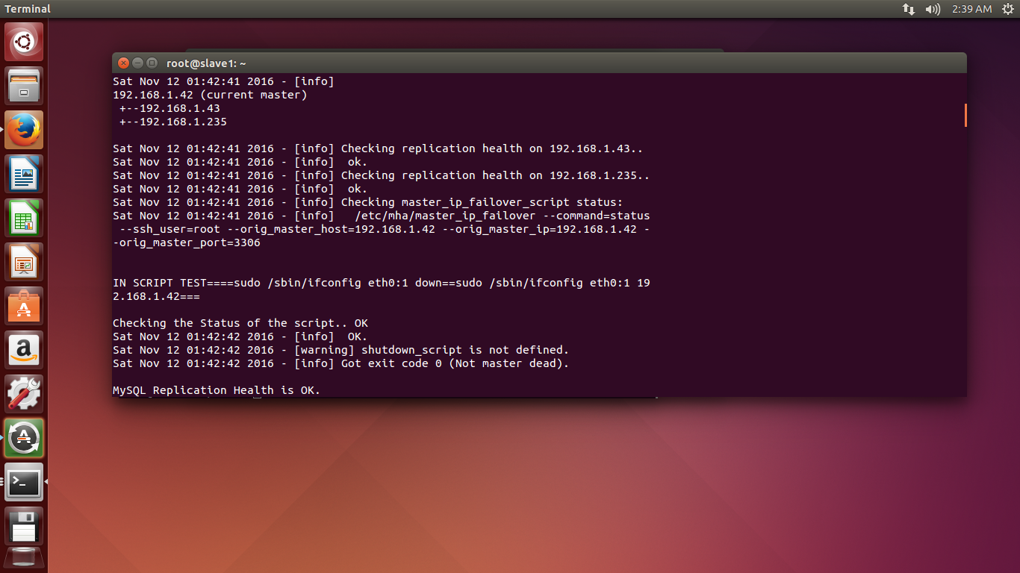

shows health is OK

configured MySQL replication, installed both MHA Node and MHA Manager, and configured SSH public key authentication, next step is starting MHA Manager.
MHA Manager can be started by "masterha _ manager" command on the MHA Manager server.
In our case, we will start it in background as below:
#nohup masterha_manager --conf=/etc/mha/app1.cnf < /dev/null > /var/log/masterha/app1/app1.log 2>&1 &
You can now check MHA status at any time with the command:
#masterha_check_status --conf=/etc/mha/app1.cnf

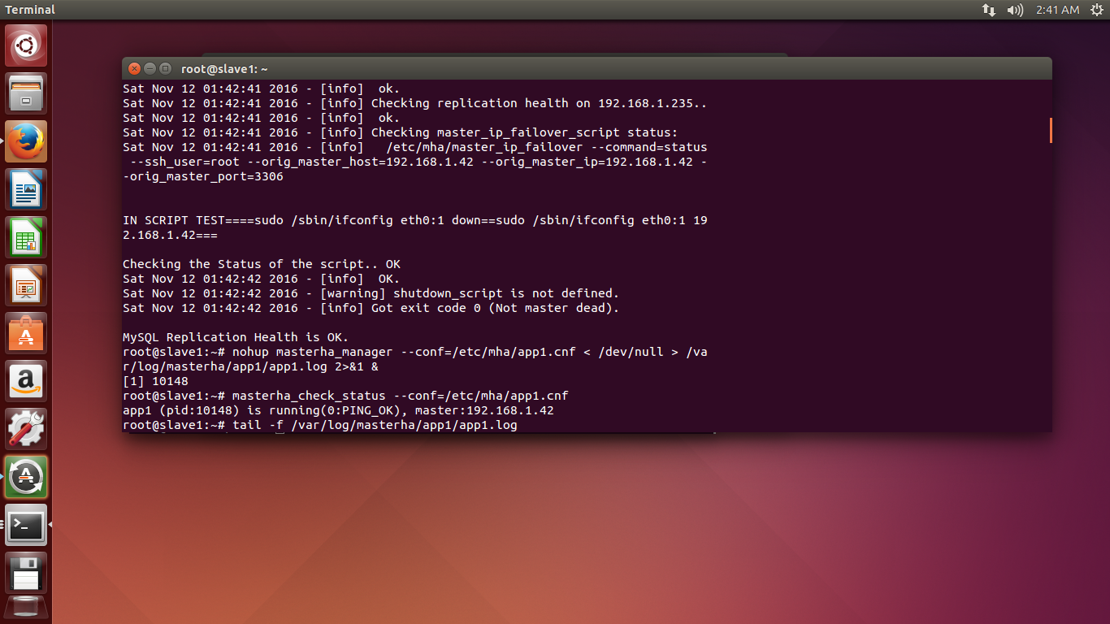

################################################################################

Now that everything is correctly configured, we will test the most important part, the master automatic failover.

On master1.com
Type the following command in the MySQL master SSH shell (or halt/reboot the server):
root@master1.com#service mysql stop

on slave1.com
Then, on the MySQL slave, (which is the MHA Manager server), check the MHA logs by typing:
#tail -f /var/log/masterha/app1/app1.log

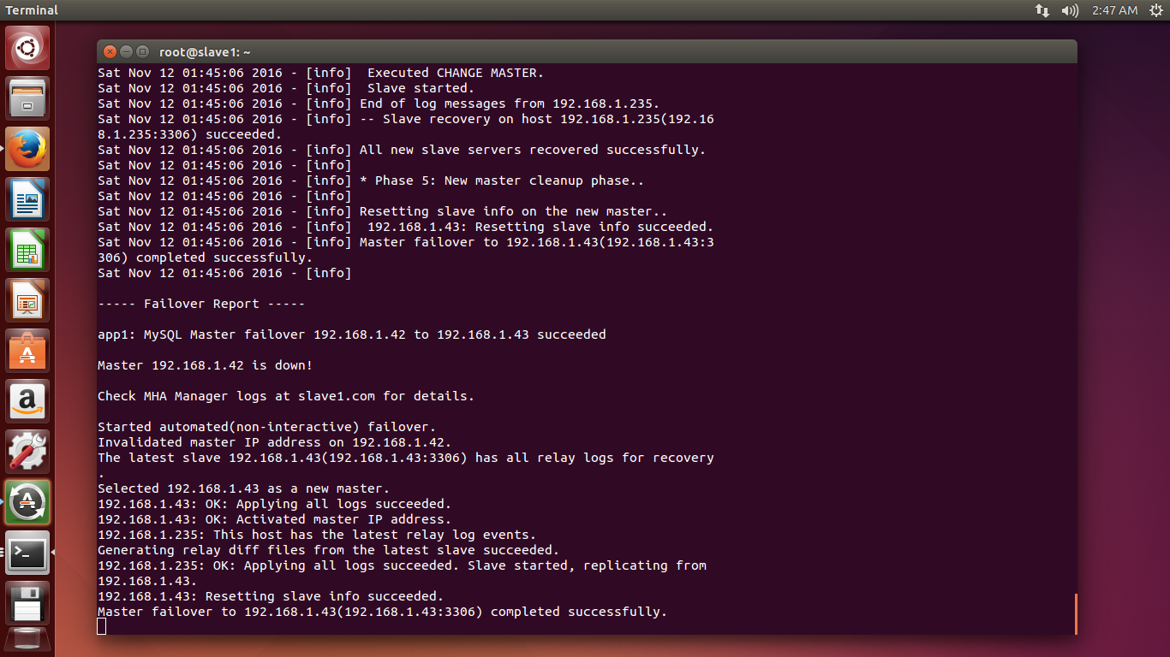
then shows master failover to 192.168.43(slave1 successfully)

now master1.com------------------------------------------>mysql stoped
slave1.com------------------>mha configured changed to new master
slave2.com----------->slave for the new master

so check the new master .....and slave2 replication from only master side to slave

link-------->>http://www.arborisoft.com/how-to-configure-mysql-masterslave-replication-with-mha-automatic-failover/

http://dbpandit.com/mysql-failover-with-mha-master-high-availability/

